BLOG TITLE : **CARRIER INSIGHTS OF DATA ENGINEER IN 2023**

AUTHOR : ASHWINI KUMAR MATHUR

BLOG ABSTRACT: Find out **how to become a data engineer** and pick up the necessary abilities. In order to be prepared for the data engineer interview, build your knowledge and portfolio.

In the ecosystem of data science, the position of data engineer is quickly gaining ground. Data Engineer was the **tech-related profession** with the biggest growth in 2019, according to the 2020 DICE Tech Job Report. With a hiring growth rate that has climbed by 35% since 2015, the position was also listed among the top 15 most outstanding emerging positions of the last five years in the 2020 LinkedIn U.S. Emerging Jobs Report.

Although some data science roles are slowing down, data engineering interviews climbed by 40% year over year, according to a report from the year 2021.

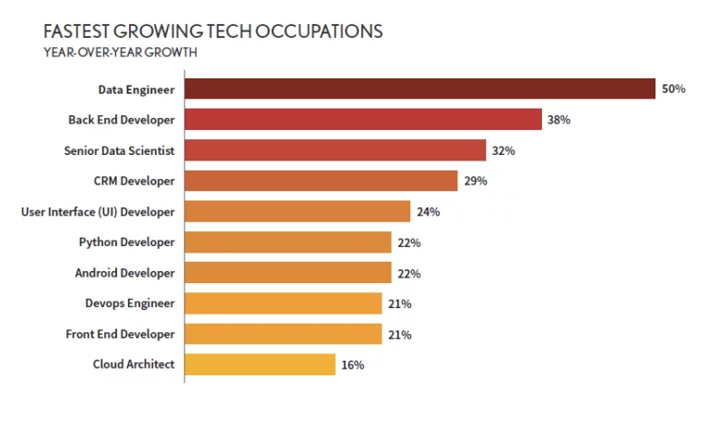**Source : Dice_2020_Tech_Job_Report**

**DATA ENGINEER LEARNING PATH:**

This blog post has all the information you require if you are thinking about becoming a data engineer. We'll discuss what a data engineer is, what their roles and responsibilities are on a daily basis, and why this is such a fantastic career choice right now.

**However, the learning route for a technical data engineer appears to be as follows:**

1. Work on your programming skills in languages like Python and Scala.
2. Study scripting and automation
3. Learn database administration and hone your SQL abilities.
4. Advanced data processing methods
5. Learn how to plan out your workflows.
6. Expand your knowledge of cloud computing with AWS and other platforms.
7. Learn more about infrastructure tools like Docker and Kubernetes.
8. Keep up to date on market trends

**WHAT IS DATA ENGINEER ?**

The groundwork for the collection, management, storage, and transformation of data within an organisation is laid by data engineers. They oversee the development, design, and upkeep of database architecture and data processing systems, ensuring that the ensuing work of analysis, visualisation, and the generation of machine learning models may be done in a seamless, continuous, secure, and efficient manner.

Data engineers, who serve as a vital link between traditional data science professions and software and application developers, are the most technical profiles in the field of data science.

The process of gathering and storing data, which is the initial step in the conventional data science workflow, is handled by data engineers. They make sure that other data science professionals, such as data analysts and data scientists, have access to the vast amount of data gathered from various sources.

On the one hand, this calls for creating and upkeep of scalable data infrastructures with high performance, availability, and capacity to incorporate new technologies. Data engineers, on the other hand, are also responsible for keeping an eye on the flow and status of data within these systems.

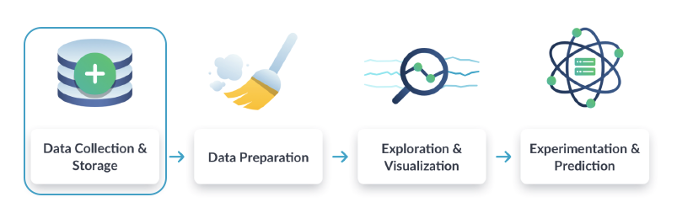

**Figure : Workflow of Data Science**

**WORK OF DATA ENGINEERS**

Data engineers are essential contributors to the creation and upkeep of any company's data architecture. They are experts in preparing huge databases for analysts to use. The data engineer develops programmes and algorithms to prepare data in an appropriate layout when an analyst wants to evaluate information.

As a result, the data engineer's daily activities primarily revolve around two processes:

The development of data extraction, transformation, and loading tasks as well as the transfer of data between various environments are all included in ETL (Extract, Transform, Load) processes.

Data cleaning procedures ensure that information reaches analysts and data scientists in a standardised and structured state.

There could be various data data sources involved, and these data sources could contain various kinds of data. The complexity of the work done by data engineers rises as the volume, diversity, and velocity of the available data do as well.

Data engineers create what are known as data pipelines to guarantee that the processes completed are timely, reliable, and scalable. Data is moved through predetermined steps in a data pipeline, such as when it is loaded from an on-premises database into a cloud service.

The automation of this movement using pipes is a crucial element. Instead of requesting that a data engineer run a programme manually each time fresh data is created, they might schedule the operation to be executed hourly, daily, or in response to a specific event.

**FINALLY LET’S TALK ABOUT HOW TO BECOME A DATA ENGINEER.**

The actions you need to take to achieve a job as a data engineer are explained here. Although the precise steps will vary somewhat depending on your present knowledge and experience, this process can help you learn how to become a data engineer from start.

Step 1: Examine the training and credentials of data engineers

Step 2: Build Your Data Engineer Skills in

Step 3: Improve your resume for a data engineer.

Step 4: Submit Your First Data Engineer Job Application

Step 5: Get ready for the interview for data engineering

**CONCLUSION**

A wonderful career option for aspirant data professionals is data engineering, one of the most in-demand jobs in the data science industry.